Potential Customers Prediction
ExtraaLearn Lead Conversion Analysis
October 7, 2026

Contents / Agenda

- Business Problem Overview and Solution Approach
- Data Overview
- EDA Results - Univariate and Multivariate
- Data Preprocessing
- Model Building
- Model Performance Summary
- Conclusion and Recommendations
- Appendix
Business Problem Overview and Solution Approach
Problem definition
ExtraaLearn is an early-stage EdTech start-up offering upskilling programs in cutting-edge technologies. It generates a large number of leads through its website, mobile app, advertising and referrals, and its representatives nurture those leads by phone and email to convert them into paying customers. Only about 30% of leads convert, so representatives spend much of their time on leads that never pay.
The business needs to:
- Predict which leads are likely to convert to paid customers, so that sales resources can be allocated to them first.
- Identify the factors that drive lead conversion.
- Profile the leads who are most likely to convert, to guide marketing and the customer journey.
This is a binary classification problem: the target `status` is 1 if the lead converted and 0 otherwise.
Solution approach / methodology
- Data overview and sanity checks: structure, data types, missing values, duplicates and the class balance.
- Exploratory data analysis: univariate distributions and outliers, conversion rate by each feature, and the five business questions (occupation, first interaction, interaction mode, lead channel and profile completion).
- Pre-processing: drop the ID, treat outliers, one-hot encode categorical features and split the data 70/30 stratified on the target.
- Model building: Decision Tree and Random Forest, each built with default settings and then hyper-tuned with GridSearchCV (every combination in a parameter grid, 5-fold cross-validation). Logistic Regression, Gradient Boosting and XGBoost were added as benchmarks.
- Model selection: the main metric is recall on converters, because a missed converter is lost revenue. Each model's decision threshold is set on training data to catch 85% of converters, and the models are then compared on precision, F1 and ROC-AUC on the unseen test set.
- Interpretation: feature importance (impurity-based and permutation), a profile of likely converters, and business recommendations.
Data Overview
The dataset contains 4,612 leads and 15 columns: an ID, 13 lead attributes and the target `status`.
Group | Feature | Type / values
Identifier | ID | Unique lead ID (dropped)
Demographic | age | Numeric, 18 to 63 (median 51)
 | current_occupation | Professional (57%), Unemployed (31%), Student (12%)
Engagement | first_interaction | Website (55%), Mobile App (45%)
 | profile_completed | High (49%), Medium (49%), Low (2%)
 | website_visits | Numeric, 0 to 30 (median 3)
 | time_spent_on_website | Numeric, 0 to 2,537 (median 376)
 | page_views_per_visit | Numeric, 0 to 18.4 (median 2.8)
 | last_activity | Email (49%), Phone (27%), Website (24%)
Lead channel | print_media_type1 / type2 | Newspaper ad seen (11%) / Magazine ad seen (5%)
 | digital_media | Digital ad seen (11%)
 | educational_channels | Heard via forums or educational sites (15%)
 | referral | Referred by someone (2%)
Target | status | 1 = converted (29.9%), 0 = not converted (70.1%)

Data quality
- No missing values and no duplicate rows. Every ID is unique, so the ID is dropped before modeling.
- The target is imbalanced (70/30), so models are judged on recall, precision and F1 rather than accuracy, and they use class weighting.
- 174 leads have zero website visits and zero time on the site. These are valid leads who engaged only through the app or other channels, not data errors.
EDA Results
Univariate analysis: ranges, outliers and distributions
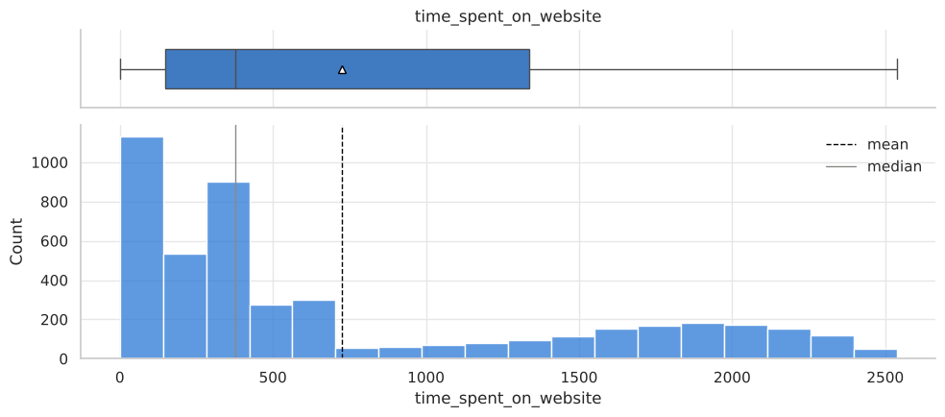
Time spent on the website: box plot and histogram
- Age ranges from 18 to 63 and is bimodal: a small cluster of students aged 18 to 25 and a large block aged 40 to 60. There are no outliers.
- Website visits (0 to 30, median 3) are right-skewed. About 3% of leads have more than 9 visits, which counts as an outlier by the IQR rule.
- Time spent on the website (0 to 2,537) has a large peak of light browsers near zero and a long plateau of engaged visitors. There are no outliers.
- Page views per visit (0 to 18.4, median 2.8) cluster between 2 and 4 with a long right tail, so about 6% of leads are outliers.
- These outliers are genuine heavy-browsing behaviour, so they were kept, and the tree-based models are robust to them.
- Among the categorical features, first interaction is split fairly evenly (Website 55%, App 45%), email is the most common last activity (49%), and each advertising channel reaches only 2% to 15% of leads.
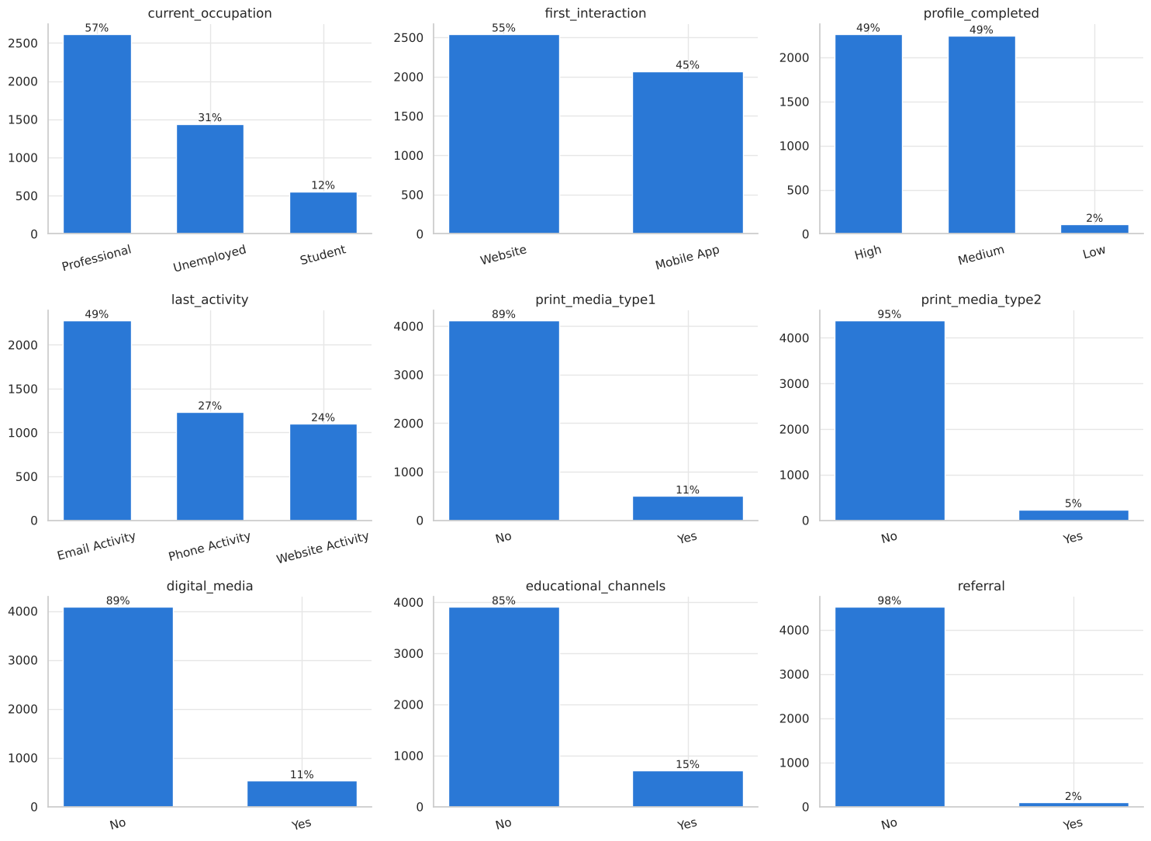
Distribution of the categorical features
Bivariate analysis: what drives conversion
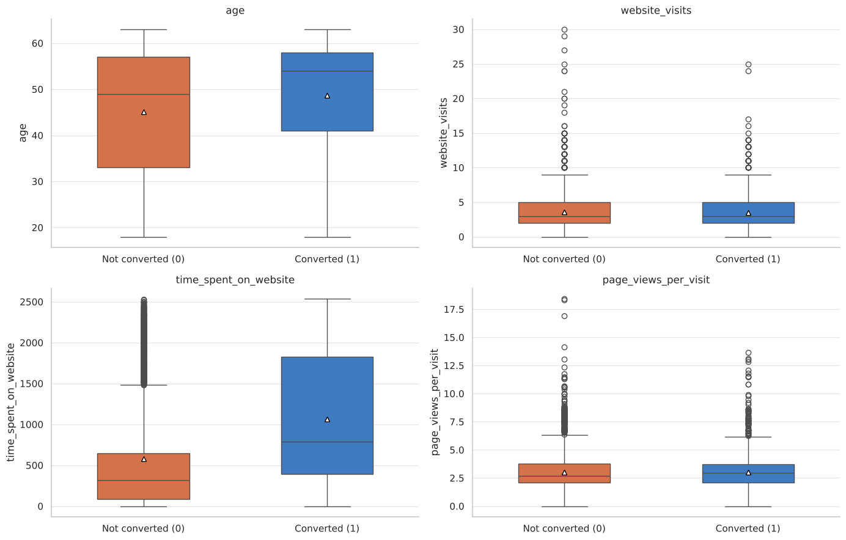
Numeric features by conversion status
- Time on the website is the strongest numeric signal. Converted leads spent a median of 789 on the site, against 317 for leads that did not convert (correlation with status 0.30).
- Converted leads are older (median age 54 vs 49).
- Website visits and page views per visit are almost identical for the two groups, so on their own they carry little signal.
- The numeric features are only weakly correlated with each other (|r| below 0.1), so multicollinearity is not a concern.
Q1. How does current occupation affect lead status?
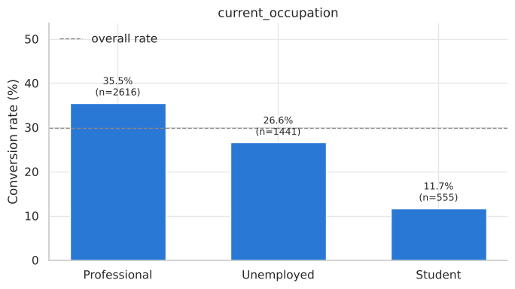
Professionals convert best (35.5%), followed by the Unemployed (26.6%). Students convert least (11.7%). Professionals are likely upskilling for career growth and can afford the programs, while students may be price-sensitive.
Q2. Does the first channel of interaction affect lead status?
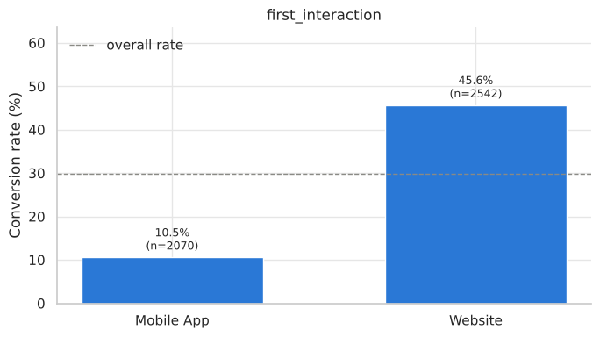
Yes, strongly. Leads whose first interaction was the Website converted at 45.6%, against only 10.5% for the Mobile App, more than four times higher.
Q3. Which way of interaction works best?
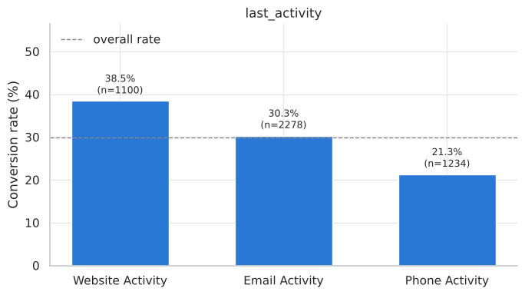
Website activity (live chat, profile updates) converts best at 38.5%, then Email at 30.3%. Phone and SMS are lowest at 21.3%.
Q4. Which lead channels have the highest conversion rate?
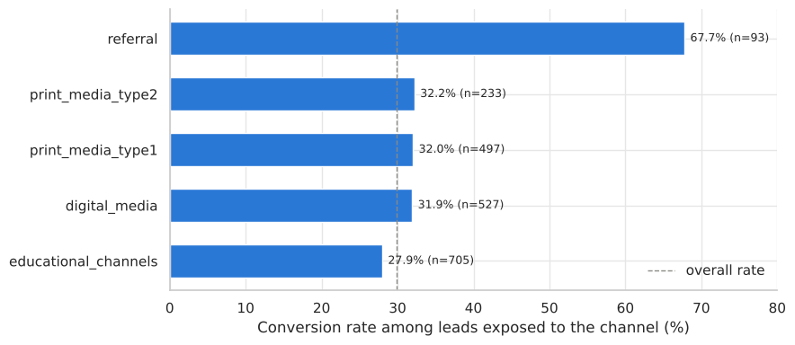
Referral is by far the best channel (67.7%), more than twice the overall rate, but it accounts for only 93 leads (2%). Newspaper, magazine and digital ads lift conversion only slightly (about 32% vs 30%), and the differences are not statistically significant (chi-square p > 0.2). Educational channels are slightly below average.
Q5. Does having more details about a prospect increase the chance of conversion?
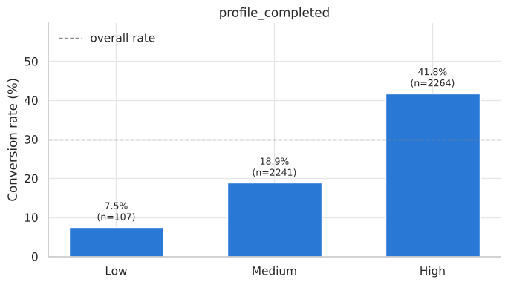
Yes. Conversion rises from 7.5% (Low) to 18.9% (Medium) to 41.8% (High) profile completion.
Multivariate analysis
First interaction | Low profile | Medium profile | High profile
Mobile App | 0.0% | 10.2% | 11.3%
Website | 12.7% | 26.0% | 66.5%

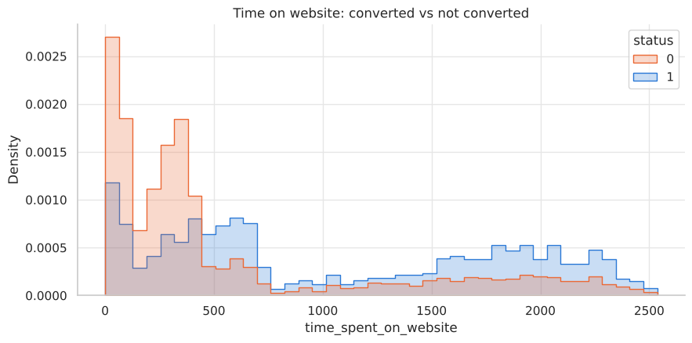
Time on the website: converted vs not converted
Key meaningful observations
- The strongest drivers are first interaction via the Website, High profile completion, time on the website above roughly 415 to 500, referral and Professional occupation.
- The drivers compound: Website-first leads with a High profile convert at 66.5%, while Mobile App leads convert at 11% or less, whatever their profile.
- Conversion jumps from under 20% to around 50% once time on the website passes roughly 500.
- Advertising channels have no measurable effect on conversion.
Data Preprocessing
- Missing values: none, so no imputation was needed.
- Duplicates and identifiers: there are no duplicates, and `ID` was dropped because it has no predictive value.
- Outliers: found only in website visits (3.3%) and page views per visit (5.6%). They were kept because they are genuine behaviour and the tree models are insensitive to them.
- Feature engineering: none. The raw features are already interpretable, and tree models learn the interactions themselves.
- Encoding: the 9 categorical features were one-hot encoded with the first level dropped, giving 16 model features.
- Train/test split: 70/30, stratified on `status` (3,228 training and 1,384 test leads). Both sets keep the 29.9% conversion rate.
- Class imbalance: handled with `class_weight='balanced'` (and `scale_pos_weight` for XGBoost) and a recall-based decision threshold.
- Scaling: applied only for Logistic Regression, because tree models do not need it.
Evaluation criterion
Error | Meaning | Business cost
False negative | A lead predicted not to convert actually would have | Lost revenue, because a real customer is neglected (the costlier error)
False positive | A lead predicted to convert does not | A representative's time is wasted

The models therefore maximise recall on converters while keeping precision reasonable. F1 and ROC-AUC are used for overall comparison.
Model Building
Decision Tree
Model | Set | Accuracy | Recall | Precision | F1 | ROC-AUC
Default tree | Train | 0.999 | 1.000 | 0.998 | 0.999 | 1.000
 | Test | 0.788 | 0.634 | 0.649 | 0.641 | 0.744
Tuned tree | Train | 0.839 | 0.877 | 0.678 | 0.764 | 0.926
 | Test | 0.820 | 0.847 | 0.653 | 0.738 | 0.911

- The default tree overfits badly: it is perfect on the training data, but recall drops to 0.63 on the test set.
- Tuning with GridSearchCV evaluated all 100 combinations of max_depth (2 to 11), min_samples_leaf (1, 5, 10, 20, 40) and criterion (gini, entropy), each with 5-fold stratified CV scored on ROC-AUC. It selected max_depth = 5, min_samples_leaf = 40, gini (CV ROC-AUC 0.919). Train and test results are now close, test recall rises to 0.85, and ROC-AUC rises from 0.74 to 0.91.
- Why ROC-AUC as the tuning metric: it rewards trees that rank converters above non-converters, and the cut-off is then set for recall. Scoring the grid on recall alone picks a depth-3 tree with recall 0.89 but precision only 0.58 and ROC-AUC 0.87, so it would flag many more leads that never convert.
- The tree splits first on first interaction, then on time on the website (about 415) and profile completion. Together these carry about 84% of the importance.
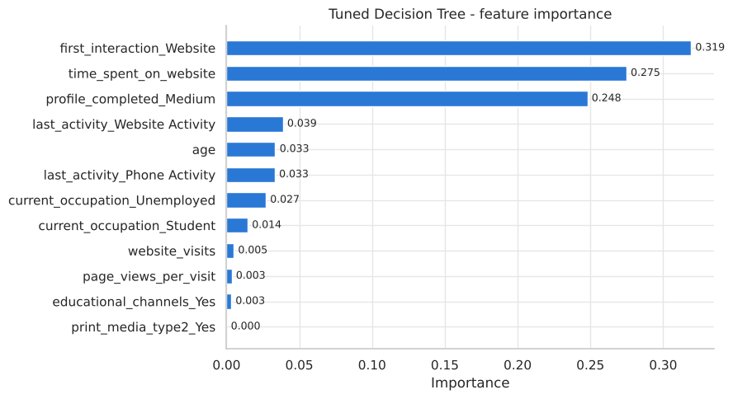
Tuned Decision Tree: feature importance
Random Forest
Model | Set | Accuracy | Recall | Precision | F1 | ROC-AUC
Default forest | Train | 0.997 | 1.000 | 0.989 | 0.994 | 1.000
 | Test | 0.849 | 0.797 | 0.725 | 0.759 | 0.916
Tuned forest | Train | 0.870 | 0.908 | 0.725 | 0.806 | 0.962
 | Test | 0.837 | 0.840 | 0.686 | 0.755 | 0.925

- The default forest also overfits (train recall 1.00 vs test 0.80).
- Tuning with GridSearchCV evaluated all 96 combinations of n_estimators (200, 500), max_depth (4, 6, 8, none), min_samples_leaf (1, 3, 5, 10) and max_features (sqrt, 0.5, 0.7), with 5-fold stratified CV scored on ROC-AUC. It selected 500 trees, max_depth = 8, min_samples_leaf = 3, max_features = sqrt (CV ROC-AUC 0.929).
- The top five combinations score within 0.0005 of each other, much less than the fold-to-fold spread (about 0.007), so the forest is not sensitive to the exact settings as long as its trees are depth-limited.
- Overfitting is controlled (recall 0.91 on train vs 0.84 on test), and the test ROC-AUC improves from 0.916 to 0.925.
- Compared with the tuned Decision Tree, the forest has similar recall with higher precision (0.69 vs 0.65) and a higher ROC-AUC (0.925 vs 0.911), so fewer follow-ups are wasted.
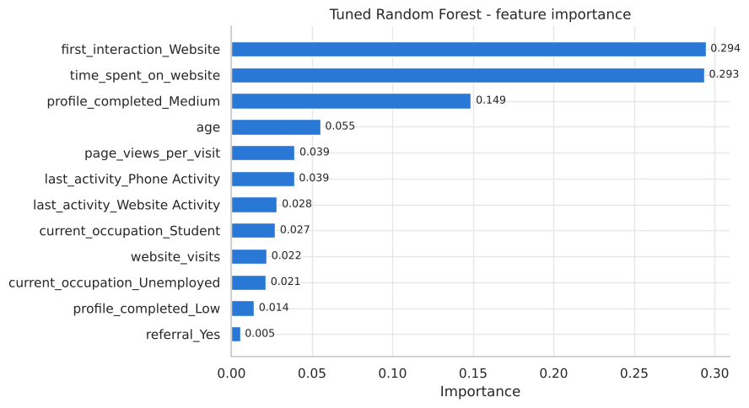
Tuned Random Forest: feature importance
Important features
- First interaction via the Website (0.29) and time spent on the website (0.29) are jointly the strongest drivers, followed by profile completion (0.15). Together they account for about three quarters of the forest's decisions, matching the Decision Tree and the EDA.
- Age (0.06), page views per visit and last activity (phone lowers the chance, website activity raises it) add smaller refinements.
- The advertising flags and referral carry almost no importance. Referral converts well but covers only 2% of leads, so it rarely changes a prediction.
- Because each tree sees a random subset of features at each split, the forest spreads some importance across secondary features, which makes it more robust than a single tree.
Additional models
To test whether a different algorithm does better, Logistic Regression, Gradient Boosting and XGBoost were tuned in the same way (5-fold CV, ROC-AUC). Each model's decision threshold was then set on out-of-fold training predictions to the highest value that catches at least 85% of converters, so all models are compared at the same recall.
Model Performance Summary
Comparison of all models (test set)
Model | CV ROC-AUC | Train recall | Test recall | Test precision | Test F1 | Test ROC-AUC
Random Forest (tuned) | 0.929 | 0.907 | 0.840 | 0.686 | 0.755 | 0.925
XGBoost (tuned) | 0.929 | 0.881 | 0.843 | 0.689 | 0.758 | 0.925
Gradient Boosting (tuned) | 0.930 | 0.887 | 0.833 | 0.691 | 0.755 | 0.924
Decision Tree (tuned) | 0.919 | 0.877 | 0.847 | 0.653 | 0.738 | 0.911
Logistic Regression | 0.868 | 0.853 | 0.847 | 0.604 | 0.706 | 0.876
Random Forest (default) | - | 1.000 | 0.797 | 0.725 | 0.759 | 0.916
Decision Tree (default) | - | 1.000 | 0.634 | 0.649 | 0.641 | 0.744

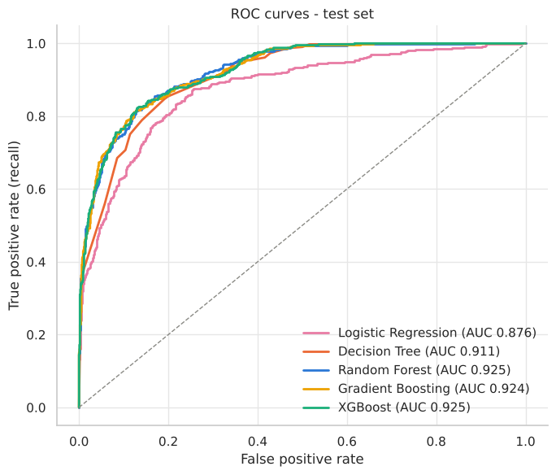
ROC curves of the tuned models on the test set
- Tuning was essential. The default trees lose 20 to 37 points of recall between train and test, while all tuned models generalise well.
- Random Forest, XGBoost and Gradient Boosting are effectively tied (test ROC-AUC 0.924 to 0.925, precision 0.69, F1 0.76).
- The tuned Decision Tree is close behind and the easiest to explain. Logistic Regression is weakest, because conversion depends on thresholds and interactions that a linear model cannot capture.
Random Forest vs XGBoost: boosting did not add to the score
Metric | Random Forest | XGBoost
Test ROC-AUC | 0.925 | 0.925
Test recall | 0.840 | 0.843
Test precision | 0.686 | 0.689
Test F1 | 0.755 | 0.758
Mean CV ROC-AUC (15 paired folds) | 0.9281 | 0.9282
Folds won | 9 of 15 | 6 of 15

- On identical cross-validation folds, the average ROC-AUC difference is 0.0000. The fold-to-fold variation in that difference (±0.0023) is far larger than the gap, so the two models are statistically indistinguishable.
- Both models rank the same three features at the top. XGBoost spreads importance more evenly across the minor features, but this does not improve its predictions.
- Why boosting adds nothing here: the signal is concentrated in a few strong features with clear thresholds, there are only 16 features and about 3,200 training rows, and a well-tuned forest already captures the key interactions. That leaves little for boosting's sequential error-correction to find.
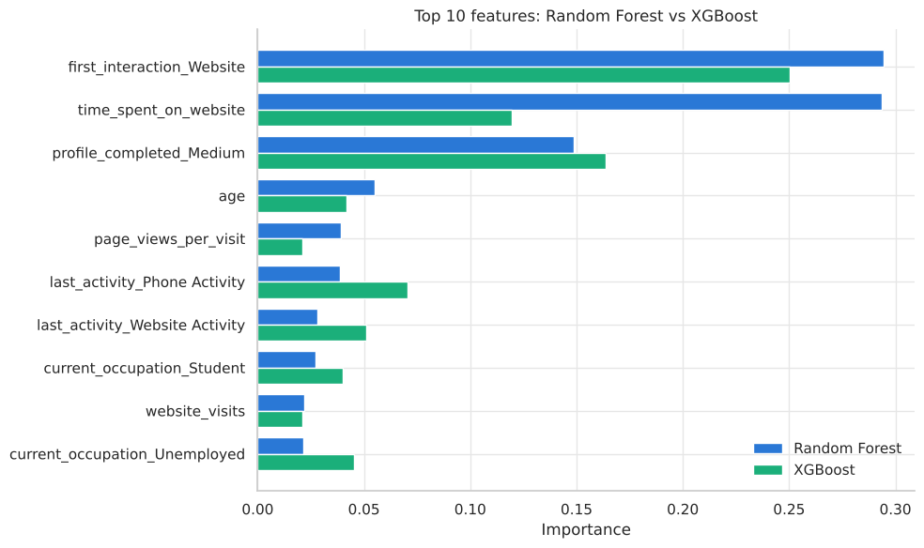
Feature importance: Random Forest vs XGBoost
Best model and reasons
The tuned Random Forest (threshold 0.50) is chosen as the final model:
- It ties for the best test performance: it catches 84% of converters with 69% precision (ROC-AUC 0.925).
- It generalises well, with a small gap between train and test scores.
- It matches XGBoost while being simpler, more robust to hyperparameters and less prone to overfitting.
- It provides clear feature importances for explaining the drivers to the business.
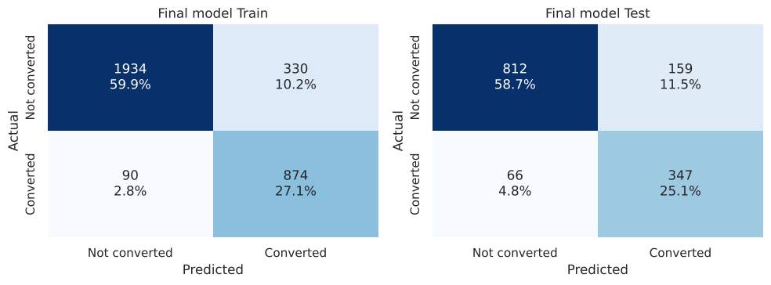
Final model confusion matrices (train and test)
On the 1,384 test leads, the model flags 506 (37%) as likely to convert. These contain 347 of the 413 actual converters (84%), and 69% of the flagged leads convert, against 7.5% of the rest.
Important predictors from the best model
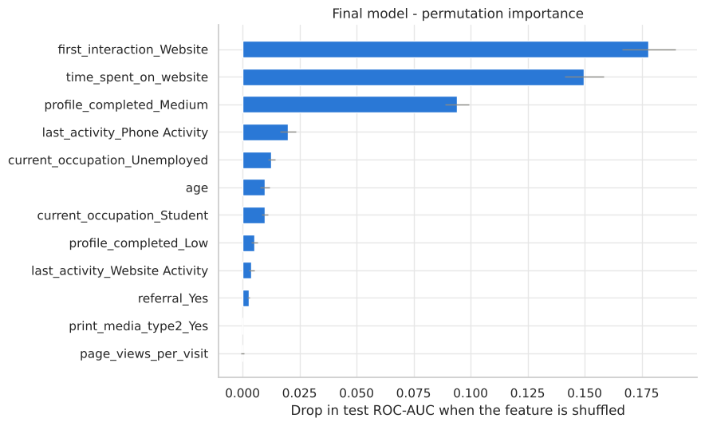
Permutation importance (drop in test ROC-AUC when a feature is shuffled)
- First interaction via the Website (vs the Mobile App)
- Time spent on the website
- Profile completion (High vs Medium)
- Last activity (phone activity lowers the chance), occupation and age: smaller effects
- Advertising flags (newspaper, magazine, digital, educational): essentially no effect. Referral helps but covers only 2% of leads.
Profile of leads likely to convert
Characteristic | Likely to convert | Unlikely
First interaction via Website | 89% | 35%
High profile completion | 71% | 36%
Median time on website | 653 | 314
Last activity is Website | 35% | 17%
Last activity is Phone | 18% | 32%
Professional | 63% | 53%
Student | 3% | 17%
Median age | 54 | 49

A typical likely converter is a working professional (or a career-changer currently unemployed) aged about 45 to 60 who first came through the website, has completed most of their profile, spends substantial time on the site (above about 415), and engages through website activity such as live chat rather than phone. Website-first leads with a High profile and more than about 415 on the site convert at 83%.
Conclusion
Proposed business actions
- Score every new lead with the model and work the 'likely' group first. Calls and follow-ups go to the roughly 37% of leads that contain 84% of future customers.
- Fix the mobile app journey. App-first leads convert at only 11%, and even engaged app leads with a High profile convert at just 23%. Review course information, pricing and checkout in the app, and route app users to live chat or the website.
- Increase engagement on the website with richer program pages, demos, webinars and live chat, because time on the site is strongly linked to conversion.
- Encourage profile completion with progress bars, reminders and small incentives (for example, a free lesson once the profile is complete).
- Build a referral programme with rewards for referrers and referees. Referrals convert at 68% but are only 2% of leads today.
- Re-examine advertising spend. Print and digital ads show no lift in conversion, so test before scaling and shift budget towards referral and website engagement.
- Focus marketing on working professionals aged about 35 to 60. For students, consider lower-priced or financed offerings.
- Use phone outreach selectively for high-scoring leads, and use email or chat for the rest.
- Retrain and monitor the model regularly as new leads arrive, tracking recall and precision.
How the analysis contributes to business success
- Higher sales productivity: 69% of flagged leads convert, against a 30% base rate, so each representative's effort is about 2.3 times more productive.
- Lower cost per acquisition: focusing on 37% of leads while still capturing 84% of converters frees roughly 60% of outreach capacity for nurturing and new leads.
- Better marketing ROI: the analysis shows which channels actually convert (referral, website) and which do not (paid print and digital ads).
- Product direction: the website-vs-app gap and the role of profile completion point to specific improvements in the customer journey.
- A repeatable, data-driven process for lead prioritisation that improves as more data is collected.
Appendix
Tuned Decision Tree (top three levels)
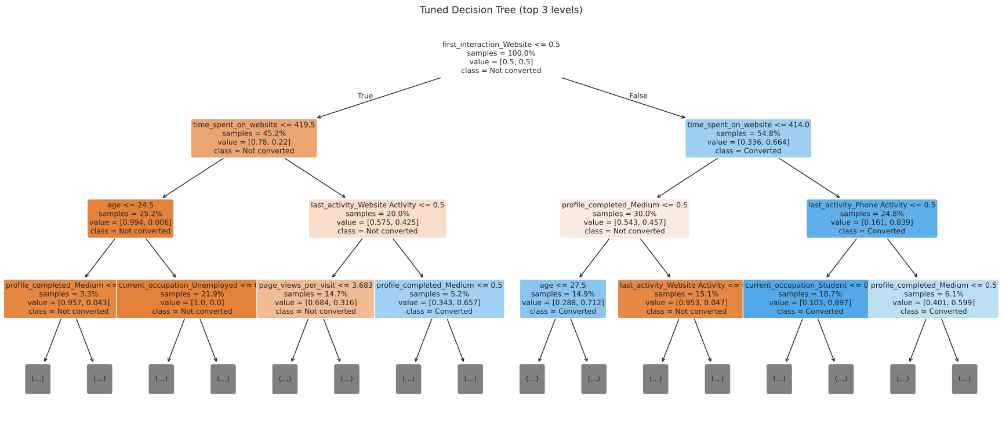
Main decision rules
- Website first, more than about 414 on the site, High profile: very likely to convert.
- Mobile App first and 419 or less on the site: very unlikely to convert, whatever the profile.
- Website first, 414 or less on the site, Medium profile: unlikely to convert.
Conversion by key segment
First interaction | Profile | Time on website | Conversion rate | Leads
Website | High | > 415 | 83.3% | 587
Website | Medium | > 415 | 56.7% | 545
Website | High | ≤ 415 | 51.6% | 663
Mobile App | High | > 415 | 23.2% | 492
Mobile App | Medium | > 415 | 22.6% | 433
Website | Low | ≤ 415 | 16.0% | 50
Website | Medium | ≤ 415 | 1.6% | 684
Mobile App | Medium | ≤ 415 | 0.9% | 579

Tuned hyperparameters
Model | Selected hyperparameters | Threshold
Decision Tree | max_depth=5, min_samples_leaf=40, criterion=gini, class_weight=balanced | 0.558
Random Forest | n_estimators=500, max_depth=8, min_samples_leaf=3, max_features=sqrt, class_weight=balanced | 0.503
XGBoost | n_estimators=100, learning_rate=0.05, max_depth=4, subsample=0.7, min_child_weight=5, scale_pos_weight=2.35 | 0.532
Gradient Boosting | n_estimators=200, learning_rate=0.03, max_depth=4, subsample=0.9, min_samples_leaf=10 | 0.347
Logistic Regression | C=0.021, class_weight=balanced, standardised features | 0.463

Additional visuals
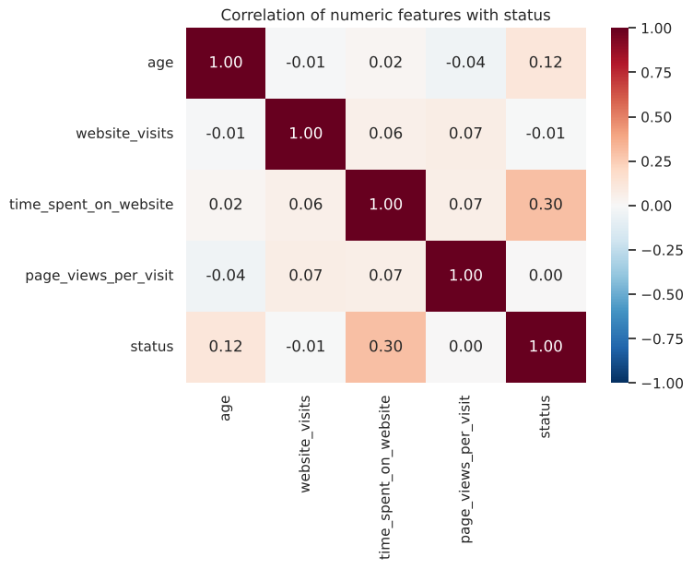
Correlation of numeric features with conversion
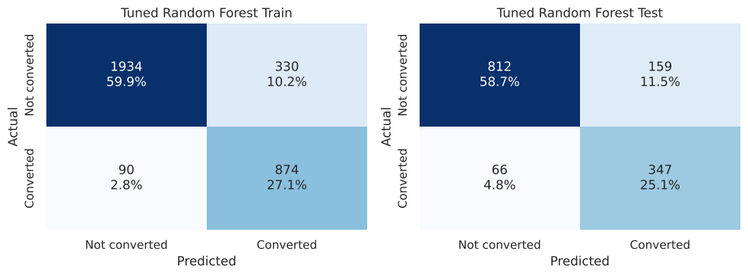
Tuned Random Forest at the 0.50 threshold: confusion matrices
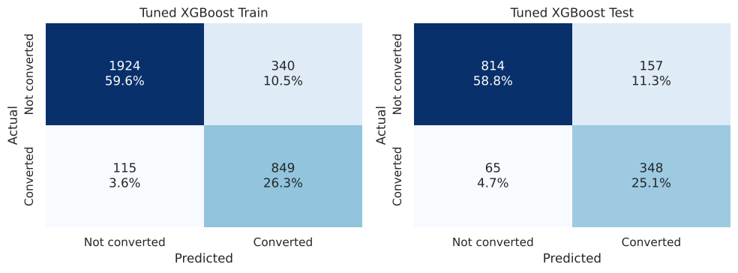
Tuned XGBoost at the 0.53 threshold: confusion matrices
Code and reproducibility
- All analysis is in the notebook ExtraaLearn - Potential Customers Prediction.ipynb (Python, pandas, scikit-learn, XGBoost, matplotlib and seaborn).
- Random seed 1 is used for the train/test split, the cross-validation folds and all models, so the results are reproducible.
- The Decision Tree (100 combinations) and Random Forest (96 combinations) were tuned with GridSearchCV; the benchmark models (Logistic Regression, Gradient Boosting, XGBoost) with RandomizedSearchCV (40 candidates). All used 5-fold stratified CV scored on ROC-AUC. Thresholds were set from out-of-fold training predictions, and the test set was used only for the final evaluation.

